Date: Friday, February 23, 2024

Location: Highbanks Metropark Nature Center, multipurpose room, 9466 Columbus Pike (US Rt 23 N) Lewis Center, OH

Registration: $45, includes coffee, donuts, and lunch

Send registration (form on following page) by Feb. 20, 2024 to:
Rick Griffin, AOP Treasurer,
937 Laurel Ave., Zanesville, OH 43701
Or register online at AOP website “store”: https://www.ohiopedologist.org/store/c1/Featured_Products.html

Tentative Program

8:30 - 9:00 AM Registration, Fellowship, and Refreshments

9:00 - 9:05 AM Kathy Sasowsky – Welcome from AOP President
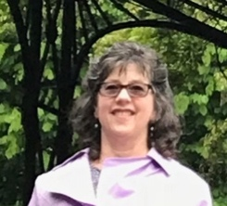
Kathy Sasowsky teaches at Cuyahoga Community College, developing courses and laboratories and instructing in-person and online on Earth Science. A certified professional Soil Scientist and registered Professional Geologist, she has researched geomorphic processes and modeling using remote sensing and G.I.S. for environmental clean-up and climate change spatial studies. Past work focused on soil investigations for sewage and other waste disposal as well as archaeologic studies. She is a proud Nittany Lion (B.S. in Agronomy /Soils and an M.S. in Geology from the Pennsylvania State University). Kathy currently serves on the AOP Executive Council as President. kathryn@sasowsky.com
9:05 – 9:20 AM Thomas Doohan – 70 Years of Carbon Dynamics: An Analysis of Soil Organic Carbon Stocks in the Sandusky River Basin

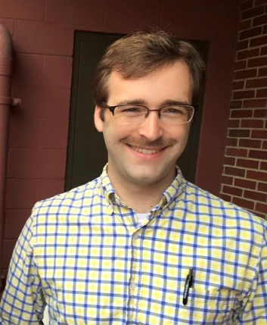
Thomas Doohan is a PhD student at Ohio State University’s School of Environment and Natural Resources. Advised by Dr. M. Scott Demyan in the school’s Soil and Environmental Mineralogy Lab, he is investigating how temporal variability of land use and inherent soil properties impact carbon stabilization at different spatial scales. He received an M.S. in soil science and a B.A. in public affairs journalism at OSU. Previously he was a staff writer for The Ashland Times-Gazette and The Daily Record in Wooster. doohan.4@buckeyemail.osu.edu
9:20 - 9:50 AM Clark Hutson – H2Ohio Program, Ohio Dept. of Agriculture

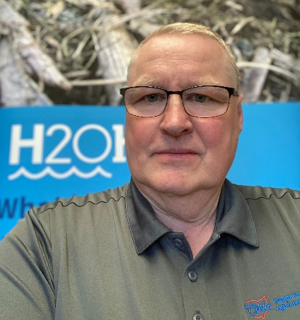
Clark Hutson is the H2Ohio Western Lake Erie Basin (WLEB) Program Coordinator, for the Ohio Department of Agriculture. Clark’s role is to oversee implementation of ODA’s efforts to encourage widespread adoption of BMPs on agricultural lands within the WLEB. Clark works with Soil and Water Conservation Districts, landowners, and partners with the goal of reducing total phosphorus loading by 40% by 2025. Clark has spent over 30 years working with agriculture producers and rural landowners in Northwest Ohio, helping them in understanding the economic and environmental impacts of the decisions they make and the actions they take while keeping their agriculture operations profitable and sustainable. Clark has a B.S. in Agriculture Education from The Ohio State University and a M.B.A. from Tiffin University. He is a Past President of the All-Ohio Chapter of the Soil & Water Conservation Society. Clark and his wife Beth live near Tiffin Ohio in Seneca County. Clark is also involved with two International Service Organizations; he is a member of the Tiffin Kiwanis Club and member and Past President of the Rotary Club of Tiffin. clark.hutson@agri.ohio.gov

9:50 – 10:15 AM Toshi Mizuta – Pedometrics: Soil and AI
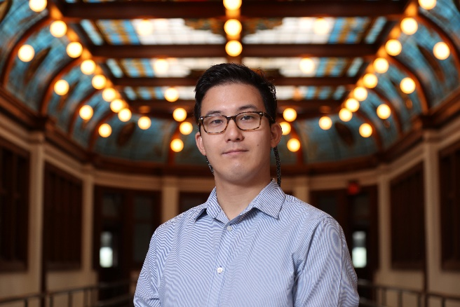
Katsutoshi (Toshi) Mizuta, Ph.D., possesses a diverse skill set and a passion for advancing environmental sustainability, particularly in the realms of soil health, climate-smart agriculture, and ecosystem services. His expertise extends across a spectrum of domains, ranging from orchestrating lab-based biogeochemical incubation studies to harnessing the power of AI technologies and proximal/remote sensing for large-scale data mining endeavors. His commitment lies in crafting tools that facilitate informed decision-making, steering us towards economical and sustainable management practices in the pursuit of global food security and effective responses to climate change challenges. While he works as a part-time postdoc researcher at University of Minnesota, he is actively engaged in education about Earth Science, Soil Science, and Digital Agriculture at Ohio Wesleyan University as an assistant professor. His academic journey includes both M.Sc. and Ph.D. degrees from the University of Florida, with his primary focus encompassing soil, water, and ecosystem sciences, complemented by a minor in food and resource economics. His collective endeavor focuses on the development and commercialization of cutting-edge in-season fertilizer application technology along with soil health practices. This pursuit is driven by his commitment to secure economic, agronomic, and environmental advantages for farmers. toshim@owu.edu

10:15 – 10:30 AM Break

10:30 – 10:45 AM Alec Ogg – Assessing the relationship between agricultural land management practices and soil carbon across the Ohio landscape

Alec Ogg’s interest in soil science stemmed from his humble beginnings in northwest Ohio where he competed in high school soil
judging competitions and participated in the family grain and beef
cattle operation. Alec graduated from Ohio State in 2022 with his BS in Environment and Natural Resources specializing in Soil Science. He is currently a graduate student at The Ohio State University. Advised by Dr. Scott Demyan, Alec is working on an international on-farm carbon farming assessment. The primary goal is to better understand the relationship between agricultural management practices and soil carbon. ogg.58@buckeyemail.osu.edu

10:45 – 11:00 AM Julie Weatherington-Rice – Tutorial of the Soilweb: Online Soil Survey Browser developed by California Soil Resource Lab at the UC Davis, UC-ANR, and in collaboration with the USDA NRCS

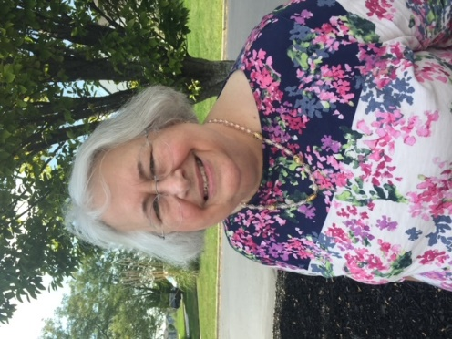
Julie Weatherington-Rice was born to be a natural scientist as she has been looking at rocks, plants, critters and soil all her life. She holds a BS in Earth Science Education, an MS in Geology and a PhD in Soil Science all from The Ohio State University. Julie is currently, semi-retired from Bennett & Williams Environmental Consultants Inc. which specializes in groundwater public water supplies and protecting our soil and water. Moreover, she spends most of her time working with allied professionals and citizen scientists, trying to demystify the fields of geology, soil and water. She lectures, prepares training materials, and coordinates the AOP Education and Scholarship efforts. She also serves as the AOP Newsletter editor. Julie lives in Worthington, Ohio with her daughter Susan Rice. edjulier@icloud.com

11:00 – 12:00 Noon Dr. Berry Lyons – Soils in the Ice-Free Regions of Antarctic: What is Their Composition and What Do They Tell Us About Climate History?
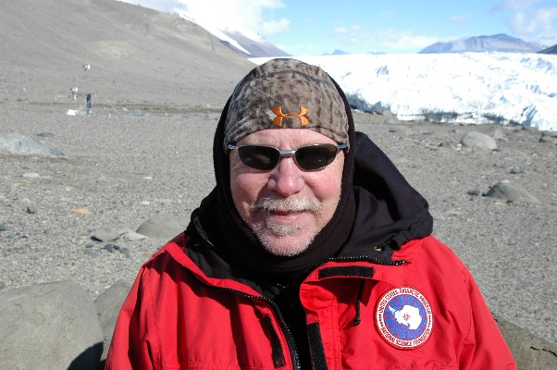
W. Berry Lyons is a College of Arts and Sciences Distinguished Professor of Earth Sciences and a University Distinguished Scholar at The Ohio State University. He is a former Director of the Byrd Polar and Climate Research Center and a former Director of the School of Earth Sciences at OSU. Prior to his arrival at Ohio State, he was a faculty member at the University of New Hampshire, University Nevada, Reno, and the University of Alabama. Although trained as a chemical oceanographer, he and his research group have been interested in terrestrial water systems for the past few decades, working on such topics as the relationship between chemical weathering and erosion, the role of climate change, urbanization and agricultural practices on water quality, The utilization of inorganic chemicals and isotopes to trace water movement, and the biogeochemistry of polar environments. In addition to his group’s work on lakes and rivers and streams, he has also published papers on the inorganic geochemistry of precipitation, soils, dust and sediments. lyons.142@osu.edu

12:00 – 1:00 PM Lunch – City BBQ

1:00 – 1:15 PM Jordan Pitt - Electromagnetic Induction Techniques for Investigating Soil Functioning on Pipeline Rights-of-Way

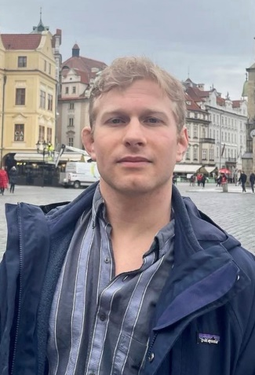

Jordan earned his undergraduate degree from Reinhardt University (north Georgia) with a BS in Biology. After graduating, he spent 2 years as a drone pilot creating 3D maps for engineering and accounting decision making. His interests in the utilization of technology for ecological decision-making lead him to take an interest in the work of his advisor, Dr. Scott Demyan. He is currently a first-year master's student at The Ohio State University School of Environmental & Natural Resources specializing in the field of soil science. pitt.64@buckeyemail.osu.edu

1:15 – 2:15 PM Jeni Ruisch – Beneath the Surface: Hidden Arthropods in Leaf Litter and Soil

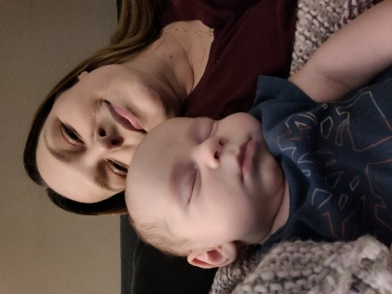
Jeni Ruisch is the Director of Outreach for the Entomology Department at Ohio State University. She curates the Insectary, a collection of ~150 species of live arthropods used for research and education. These animals travel around the state of Ohio and beyond, meeting the public. Jeni hopes to quell fears, bust myths about bugs, and introduce people to science and the wonderful world of arthropods. She has over 20 years of experience working with exotic animals in captivity, and her background is in human and animal cognition and behavior. This unique cocktail of experience and education allows her to act as a bridge between humans and the animals that surround them. When she is not working, she is hanging out with her husband, brand-new baby and their plethora of pets, and probably lifting up rocks somewhere hoping to find cool bugs. ruisch.2@osu.edu

2:15 – 2:30 PM Break

2:30 – 4:00 PM Business Meeting

