Join our Membership  The Association includes four categories of membership.  Student Members are enrolled in an institution of higher education offering course work in pedology, soil science, soil management, or related subjects and are actively engaged in preparing to enter the profession or have an interest in pedology.  Affiliate Members are mostly involved in land use planning activities that use soil survey information.  Soils Professionals are presently, or were formerly, engaged in a soil resource related profession.  Honorary Members are recognized for outstanding contributions in soil science.  Apply at:  https://www.ohiopedologist.org/membership.html | 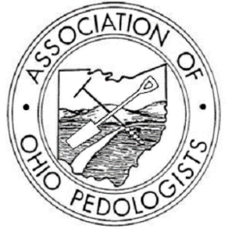  Join Us in Advancing Soil Science!  Visit our website to learn more about the Association of Ohio Pedologists and how you can become involved in shaping the future of soil science in Ohio. Whether you're a seasoned soil scientist or just beginning to explore the wonders of soil, join our community today and start your soil science journey with AOP.  https://www.ohiopedologist.org/ | Association of Ohio Pedologists  - Advancing Soil Science in Ohio
Welcome to AOP  As a nonprofit, scientific, and education organization, the Association of Ohio Pedologists is committed to promoting the professional development and recognition of soil scientists in Ohio. Explore our website https://www.ohiopedologist.org/ to learn more about our mission, objectives, and how you can get involved.  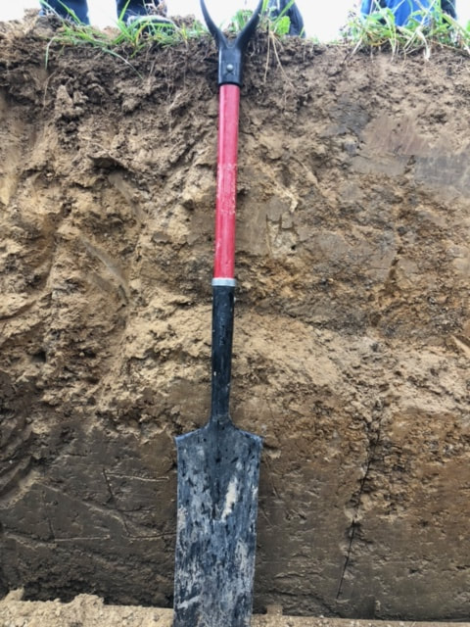 | Association Objectives  - Advance the profession of soil science through classification, mapping, and interpretation.  - Enhance the stature of professional soil scientists in Ohio.  - Promote high-quality standards among soil scientists.  - Foster recognition of the importance of soil science in government and the private sector.  - Collaborate with colleges and universities to adapt curricula to the needs of soil scientists.  - Serve as a communication platform between soil scientists and allied disciplines.  - Advocate for state registration and certification of soil scientists.  - Support good land use and environmental programs through soil resource information. | 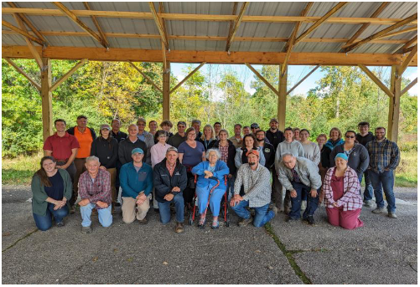  Meeting info is posted at:  https://www.ohiopedologist.org/events.html  AOP Members meet twice annually for continuing education, networking, & to discuss all things soil!  Newsletters can be found at: https://www.ohiopedologist.org/2011-present.html

